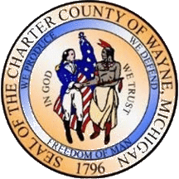 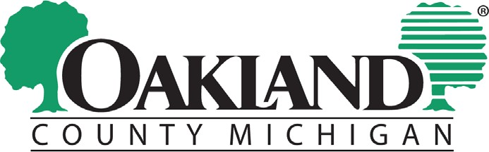 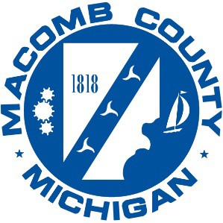

# Tri-County Summit 2022

# Sponsorship Form

|  |
| --- |
|  |
|  |

Organization/Sponsor Name:

Contact Person:

Title:

Address:

City, State, Zip:

Email:

Phone:

Sponsorship Level:

Premier - $3,000 +

Includes: 5 seats, exclusive logo placement, verbal acknowledgement at event, and invitation to VIP Reception

Lead - $2,000

Includes: 4 seats, general logo placement, and verbal acknowledgement at event

Sponsor $1,000

Includes: 3 seats and general logo placement

Supporter $500

Includes: 2 seats and general logo placement

Other

# Please submit this form by September 16, 2022

Send form and contributions payable to:

Macomb County Board of Commissioners

Tri-County Summit 2022

1 South Main Street, 9th Floor, Mount Clemens, MI 48043

tricountysummit@macombgov.org

**Please submit a copy ready logo via email to: tricountysummit@macombgov.org**